Terraform Task

Create a VPC with a public and private subnet, Internet Gateway and a default Route Table by using variable block

1. Create a VPC using VS code.

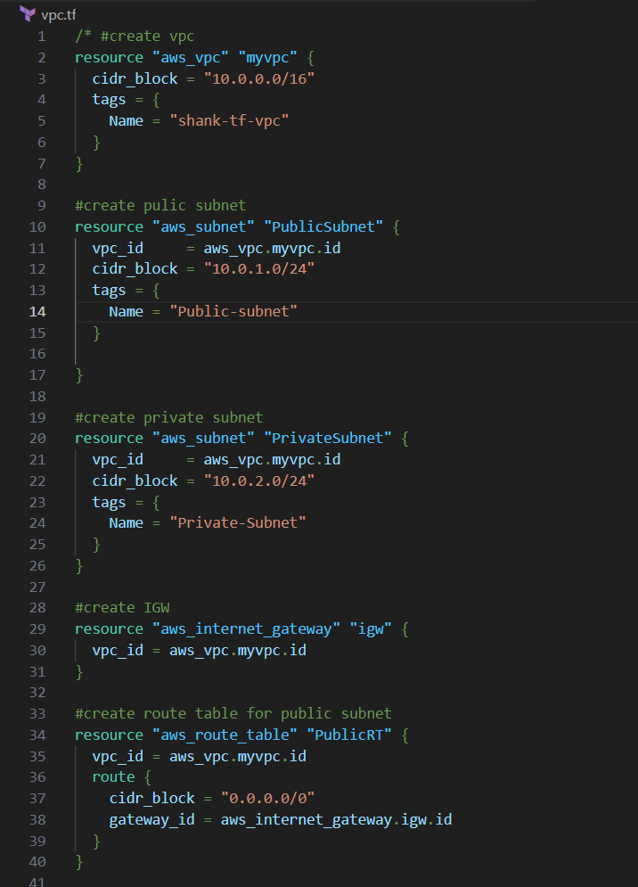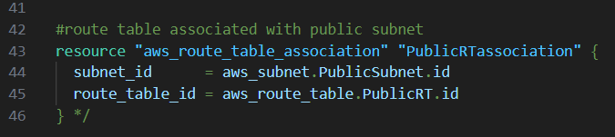

1. Make changes as per your requirement.
2. Like VPC name, cidr block .
3. After completing the code go to the ubuntu and apply following commands.

cd /mnt

ls

cd Shashank -> folder name

ls

cd terraform-task -> my terraform folder

ls -> my vpc files

terraform init

terraform plan

terraform graph

terraform fmt -> for indentation

terraform apply

